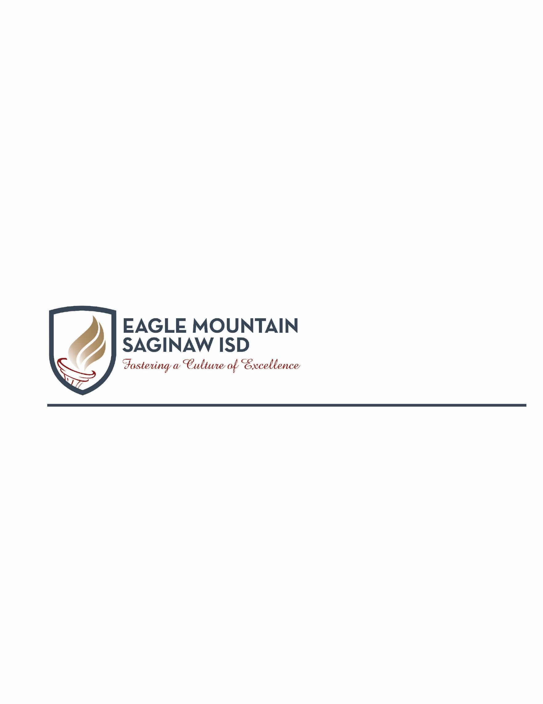

Dear Parent or Guardian,

Personal Financial Literacy will develop citizens who have the knowledge and skills to make sound, informed financial decisions that will allow them to lead financially secure lifestyles and understand personal financial responsibility. The knowledge gained in this course has far-reaching effects for students personally as well as the economy as a whole. When citizens make wise financial decisions, they gain opportunities to invest in themselves, build businesses, consume goods and services in a responsible way, and secure a future without depending on outside assistance. The economy benefits from the optimal use of resources, increased consumption, and strong local businesses. State and local governments benefit with steady revenue streams and reduced future obligations as our society ages.

During the sixth six weeks grading period, students will be engaged in course work over the following units of study:

**Unit 5: College and Postsecondary Education and Training (April 26 – May 20)**

In this unit student will consider the costs and benefits of differing post-secondary education and training opportunities. Funding of these opportunities will be examined.

Throughout the sixth six weeks grading period, student knowledge and understanding will be assessed in a variety of ways, such as:

* Interacting with Academic Vocabulary
* Thinking Maps/Graphic Organizers
* Cornell Notes
* Marking the text
* Creating/Interpreting charts & graphs
* Formative and summative assessments
* Student collaborative learning
* Quick Writes
* Pair/Share
* Use of Stems for writing
* Peer Tutoring

Please feel free to contact us if you have any questions or concerns regarding your student. We look forward to working with you and your child to ensure academic success.

Respectfully,

Personal Financial Literacy Teachers